# Lab 7 - Exploring Microsoft Sentinel Advanced Features

## Exercise 1: Getting started with Notebooks in Microsoft Sentinel

You are a Security Operations Analyst working at a company that implemented Microsoft Sentinel. You need to explore the benefits of threat hunting with Microsoft Sentinel Notebooks. You can use notebooks to:

* Perform analytics that are not provided out-of-the box in Microsoft Sentinel, such as some Python machine learning features.
* Create data visualizations that are not provided out-of-the box in Microsoft Sentinel, such as custom timelines and process trees.
* Integrate data sources outside of Microsoft Sentinel, such as an on-premises data set.

### Task 1: Exploring Notebooks

In this task, you will explore using notebooks in Microsoft Sentinel.

1. On the Azure Portal [**http://portal.azure.com**](urn:gd:lg:a:send-vm-keys) and search for [**Microsoft Sentinel**](urn:gd:lg:a:send-vm-keys) and click on **Microsoft Sentinel**.

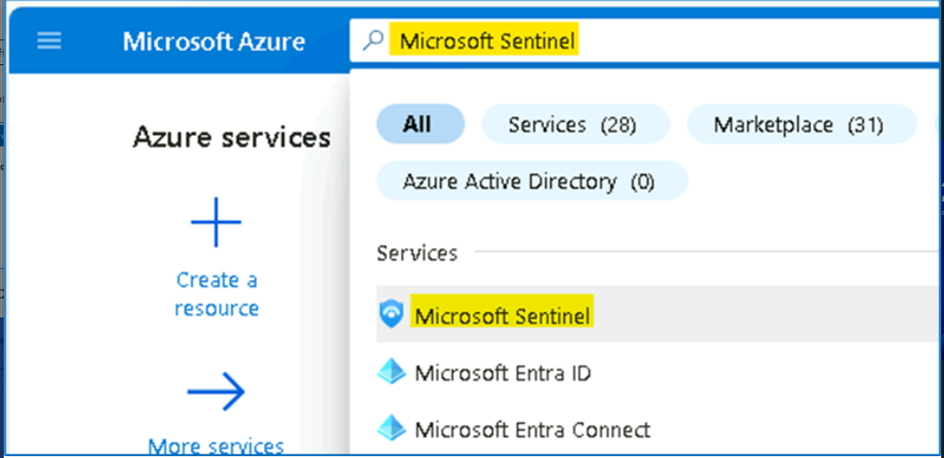

1. Select **SwrkXXXXXXX**.

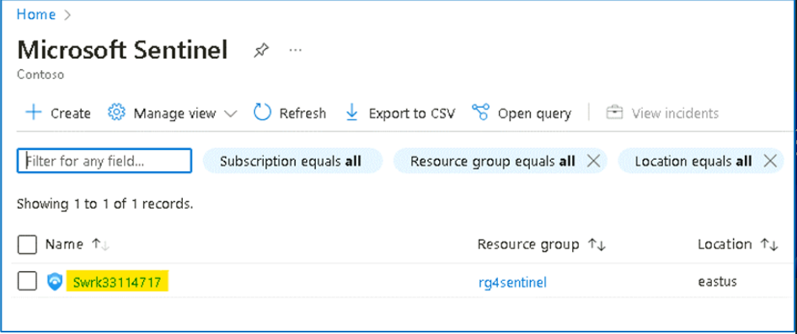

1. Now click on **Notebooks** under the **Threat management** area.

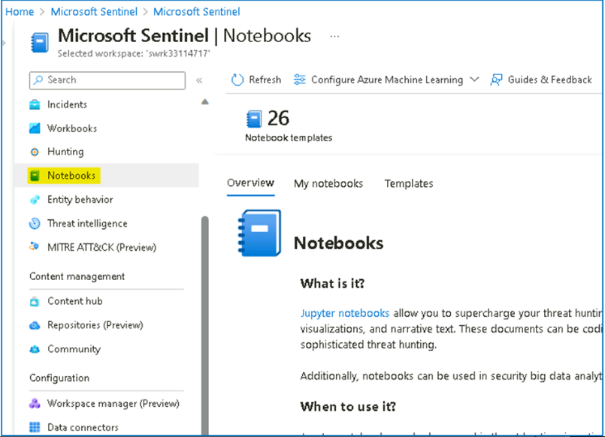

1. Next, you need to create an **AzureML** Workspace. Select **Configure Azure Machine Learning** and then select **Create new Azure ML workspace** button in the command bar.

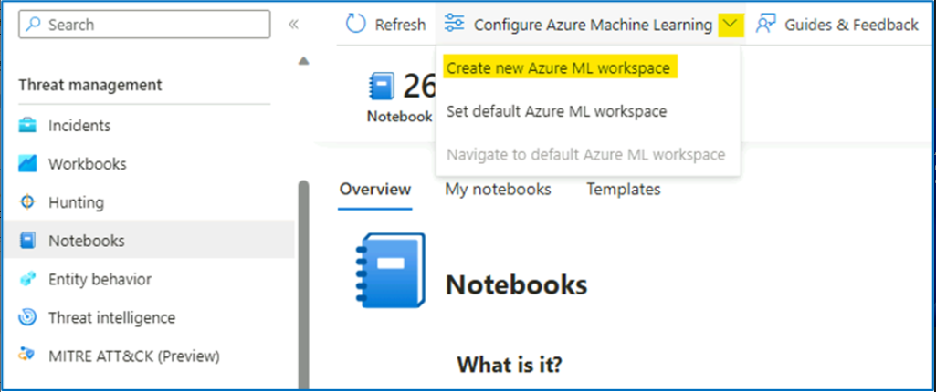

1. On the Azure Machine Learning page, provide the below details,

a. Subscription - **Azure Pass-Sponsorship**.

b. Resource group - **RG4Sentinel**

In the Workspace details section do the following:

c. Name: [**AzureMLWorkspace**](urn:gd:lg:a:send-vm-keys) .

d. Region -- **East US**

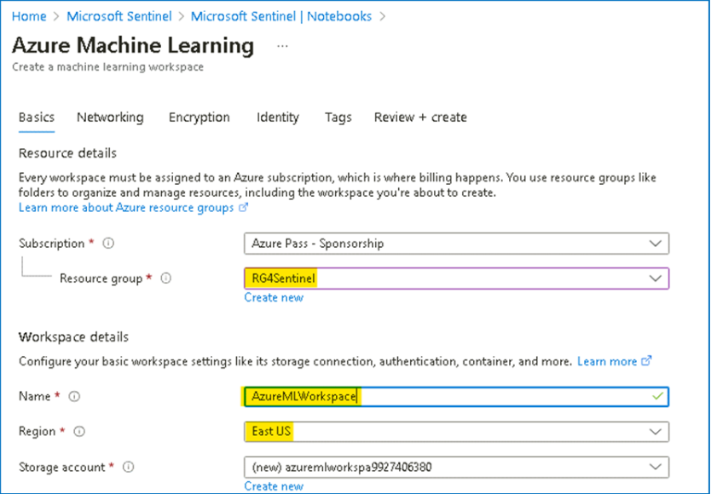

e. Keep the default **Storage account**, **Key vault**, and **Application insights** information.

f. The **Container registry** option can remain as **None**.

1. At the bottom of the page, select **Review + create**.

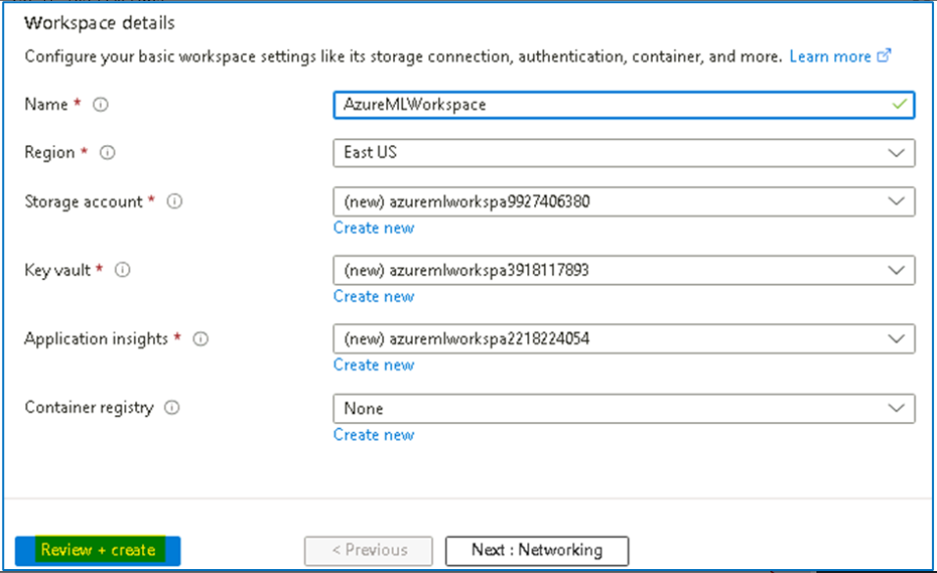

1. Once the Validation is completed, click on **Create**

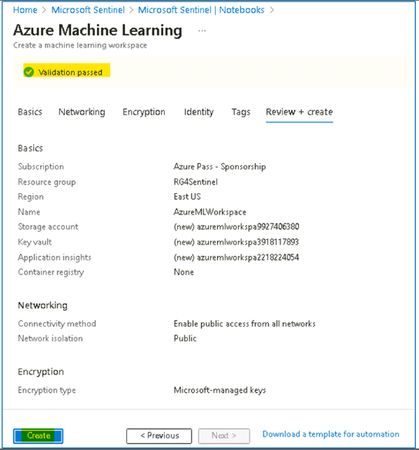

**Note:** It may take a few minutes to deploy the Machine Learning workspace.

1. Once the deployment is completed, navigate to the Microsoft Sentinel home page.

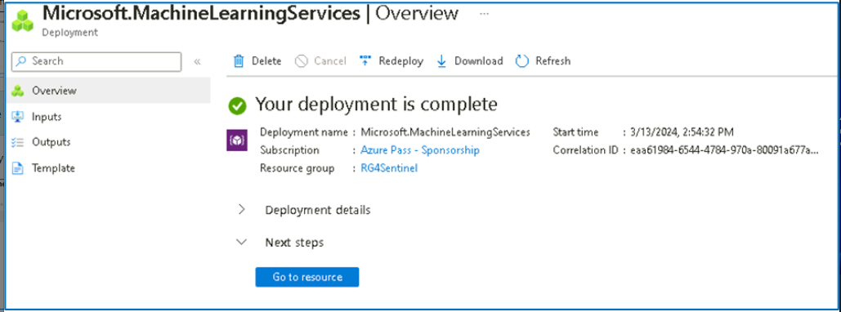

1. Once the deployment is completed, open the Microsoft Sentinel Workspace, select **Notebooks** then click on the dropdown for **Configure Azure Machine Learning** and select **Set default Azure ML workspace.**

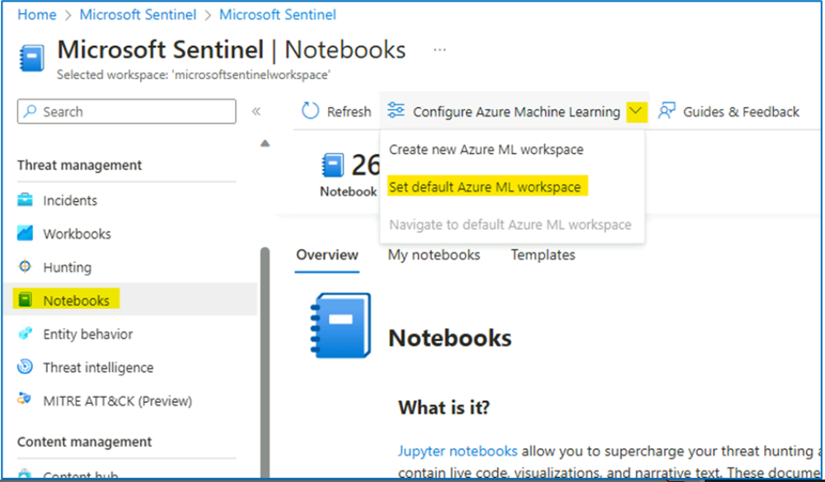

1. Under **Azure Machine Learning Workspace**, select **AzureMLWorkspace** and click **OK**.

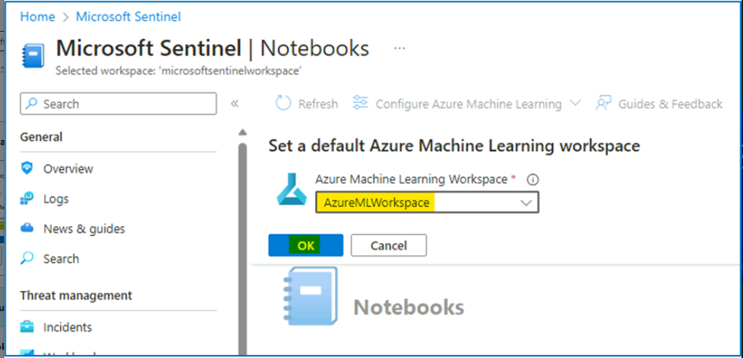

**Note** -- If the **AzureMLWorkspace** is not visible in the drop-down menu, then refresh the page and try again.

1. Select **Notebooks** again and then select the **Templates** tab from the middle command bar. And select **A Getting Started Guide for Microsoft Sentinel ML Notebooks**.

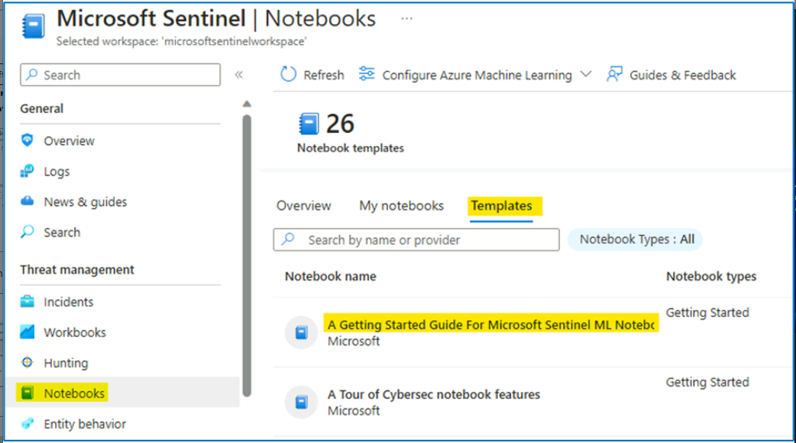

1. On the right pane, scroll down and select **Create from template** button.

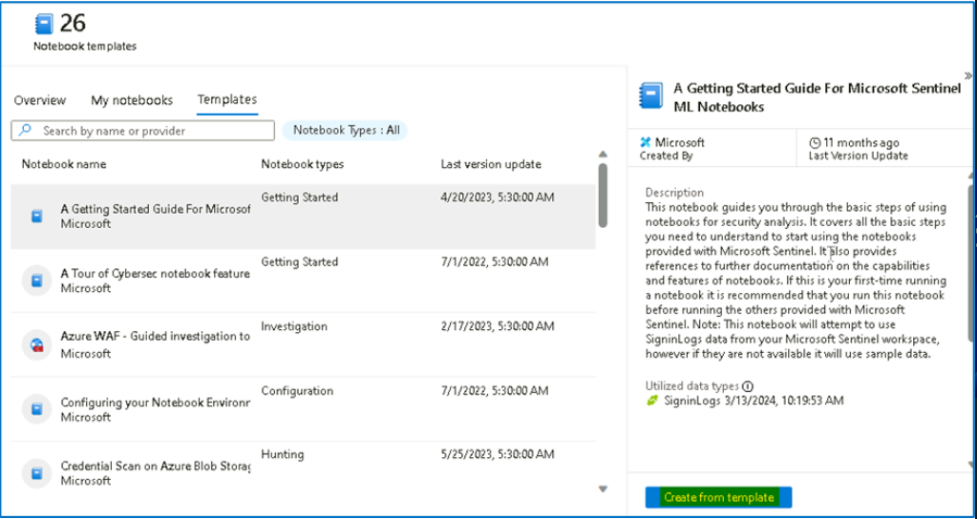

1. Review the default options and then select **Save**.

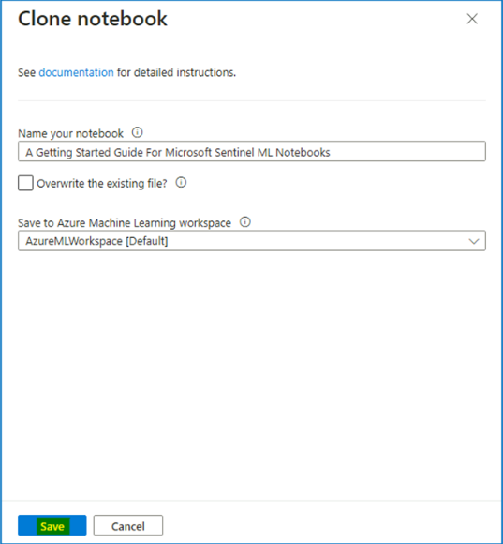

1. Once the saving is done, select the **Launch notebook** button. This will take you to the Microsoft Azure Machine Learning Studio.

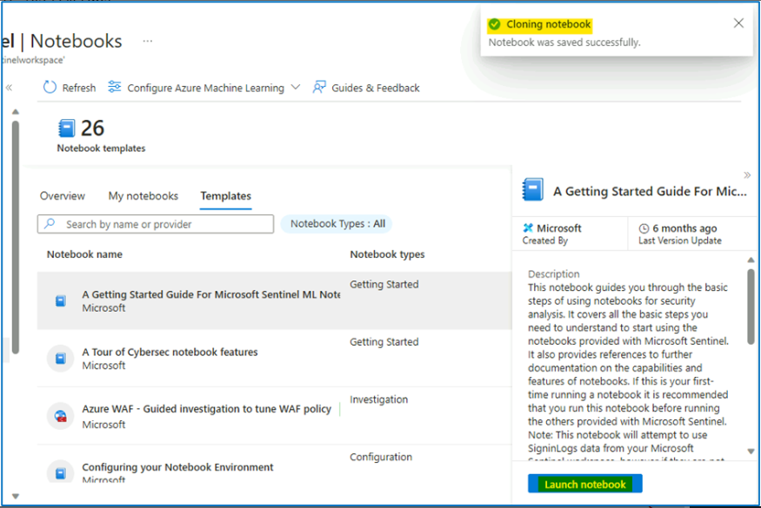

Note: You can also launch the workspace from **Notebooks** > **Configure Azure Machine Learning** > **Navigate to default Azure ML workspace.**

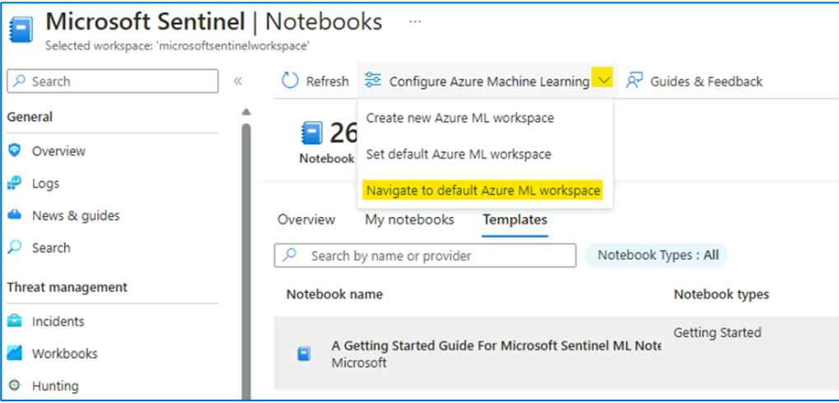

1. Click on the **All Workspaces** from the left menu, and then click on the **AzureMLWorkspace**.

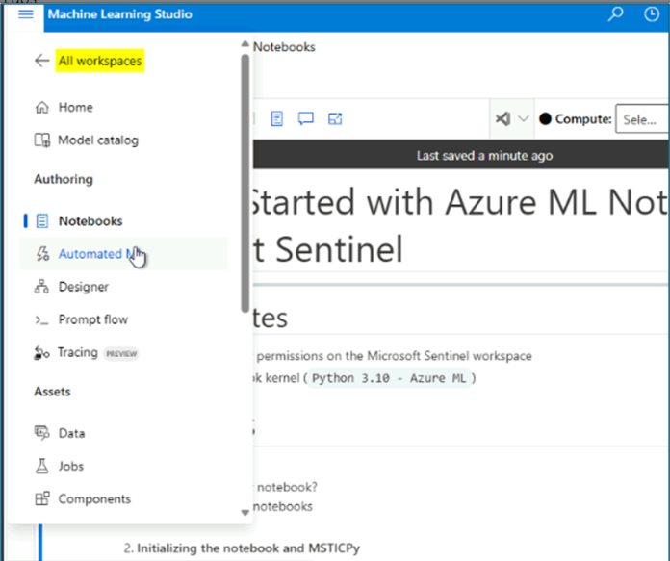

1. Press the **Cancel** button, for the survey questions and then click on **Notebooks** under Authoring.

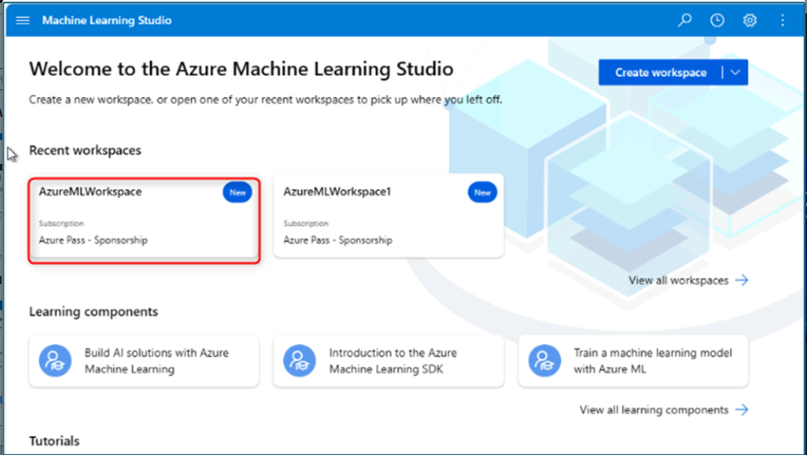

1. Select **Close** if an informational window appears in the Microsoft Azure Machine Learning Studio.

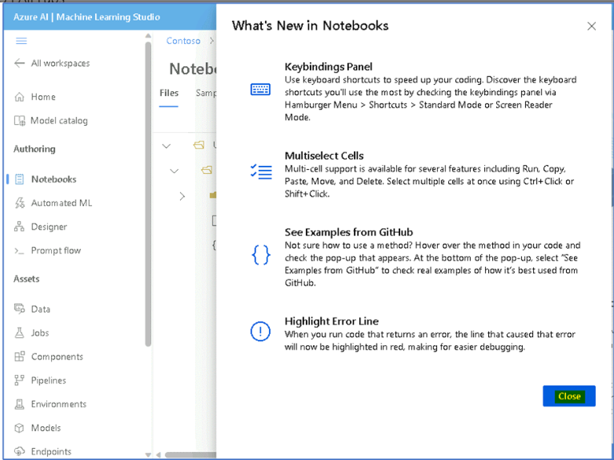

1. Click on Create compute button on the bottom right side of the screen.

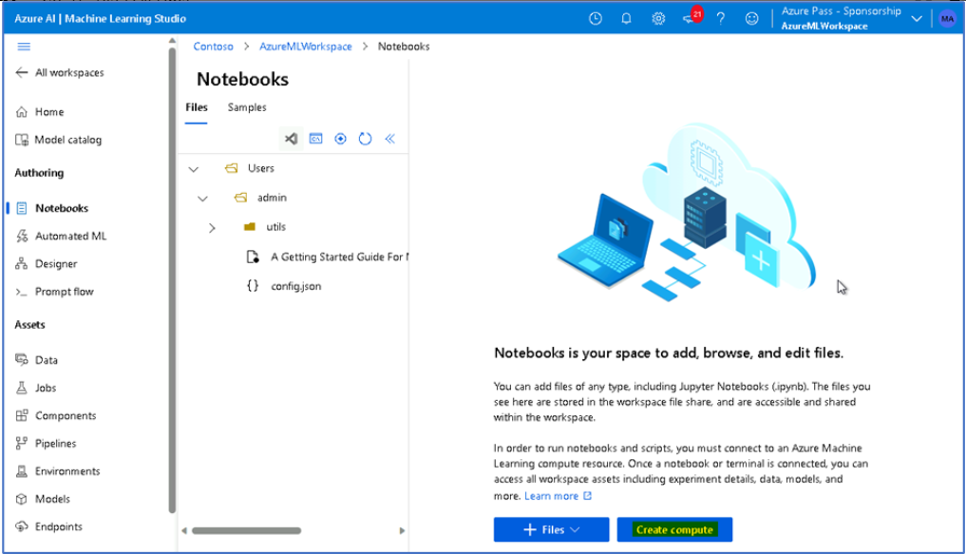

1. Provide the compute name as [**SenComXXXXXX**](urn:gd:lg:a:send-vm-keys) [Substitute XXXXXX with random to make the Compute name unique. This will identify you compute instance.
2. Scroll down and select Workload type: **Development on Notebooks and light weight testing** then click on **Review + Create** button.

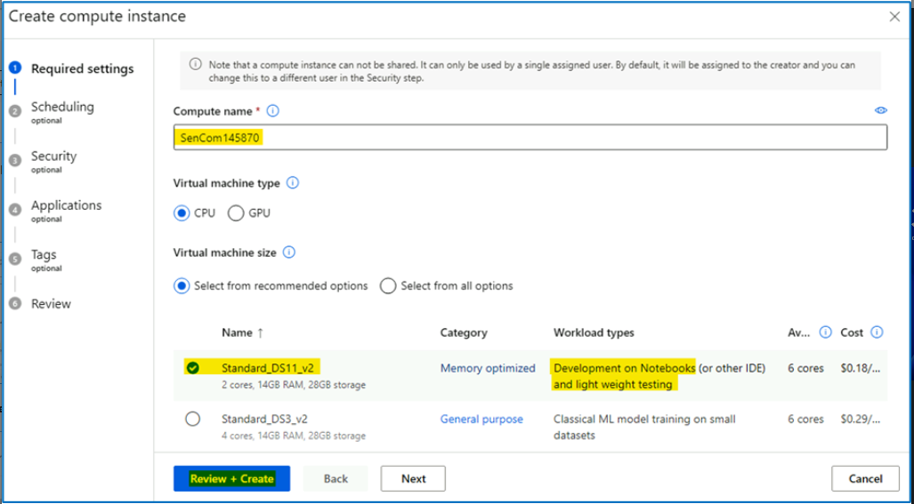

1. Select the **Create** button at the bottom of the screen.

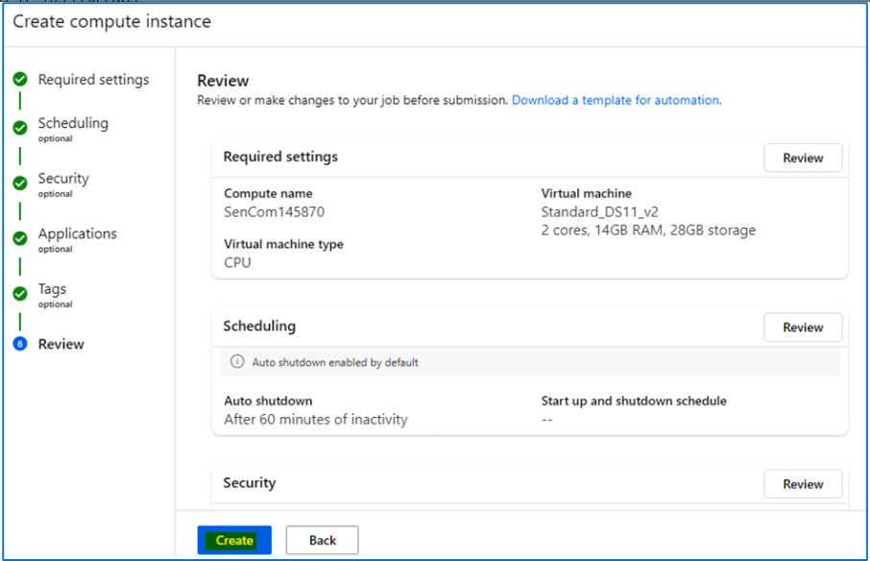

1. Close any feedback window that may appear. This will take a few minutes, you will see a notification (bell icon) when it is done and the *Compute instance* left icon turns from blue to green.

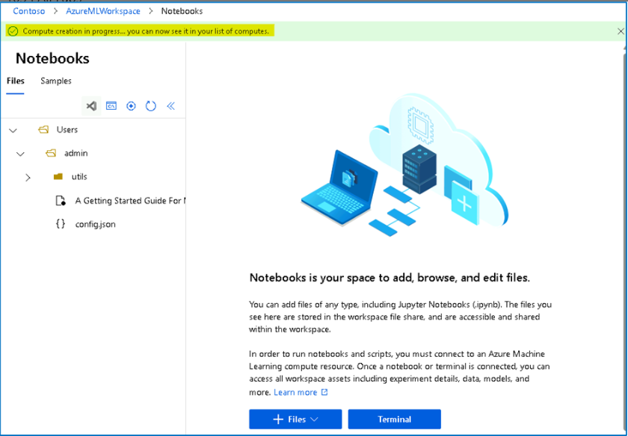

1. You should get the notification as shown in the below image after 1-2 minutes.

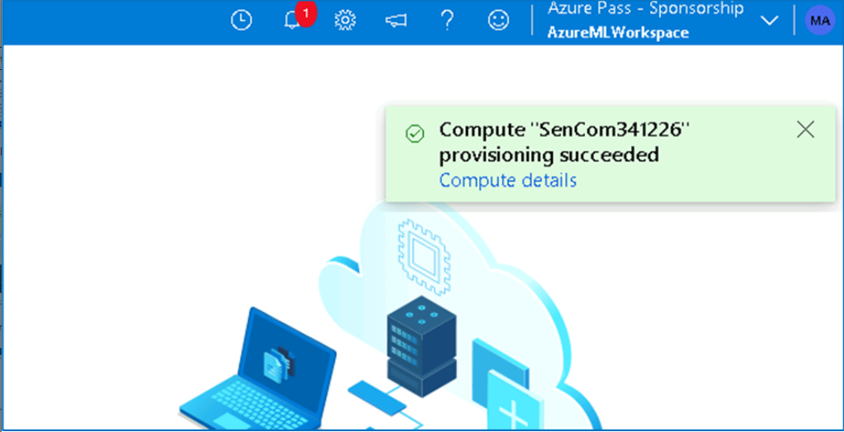

1. Click on the Terminal button after the Provision succeeded notification has appeared.

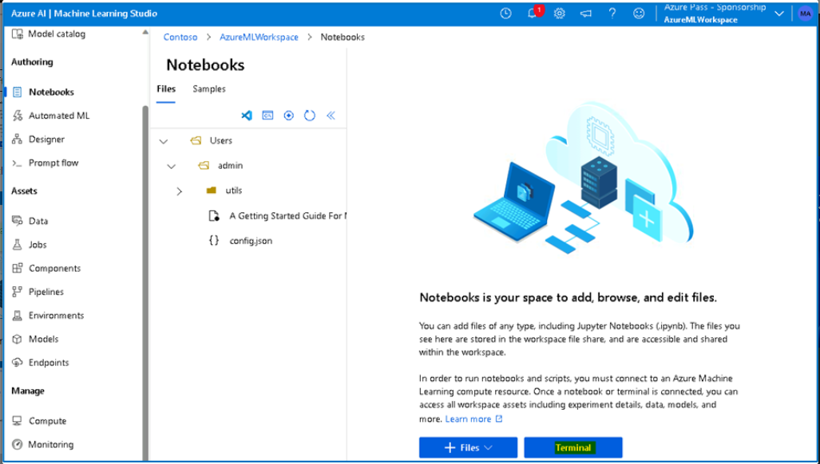

1. If the Terminal is launched correctly then no error should appear.

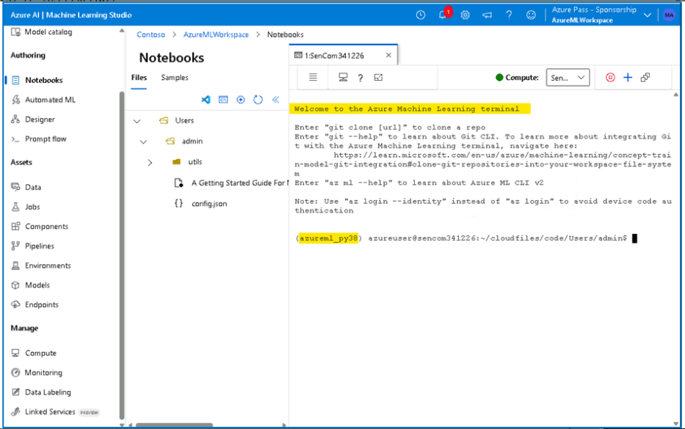

1. You have successfully created an Azure ML Compute resource.
2. From the terminal you can try the [**az login**](urn:gd:lg:a:send-vm-keys) command and authenticate to login as shown below

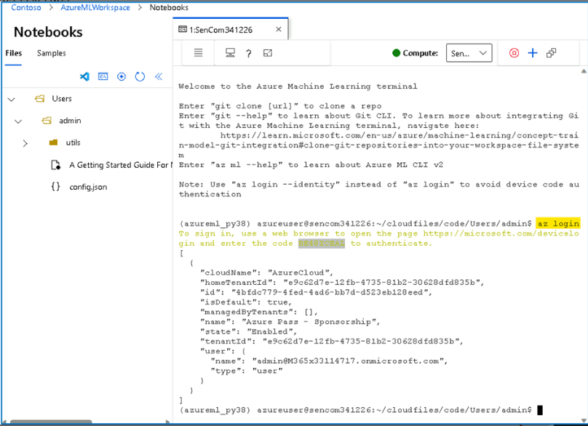

# Exercise 2: Getting started with Workbooks in Microsoft Sentinel

### Task 1: Exploring workbook templates

1. On the Azure Portal [**http://portal.azure.com**](urn:gd:lg:a:send-vm-keys) and search for **Microsoft Sentinel** and click on **Microsoft Sentinel**.

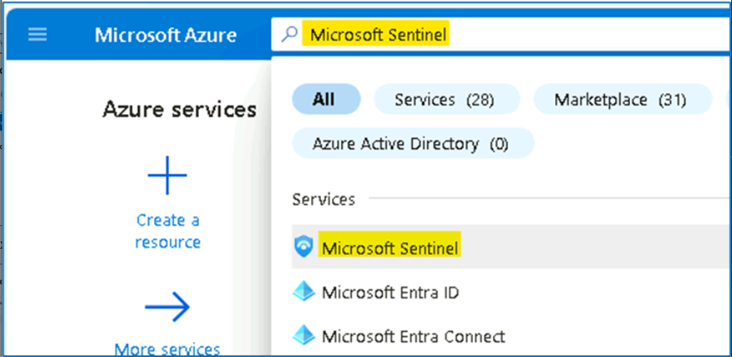

1. Select **SwrkXXXXXXX**.

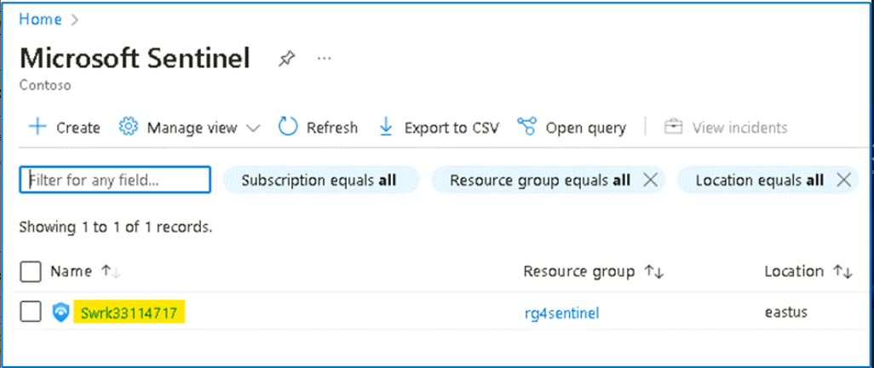

1. Now click on **Workbooks** under the **Threat Management** left blade and select the **Templates** tab.

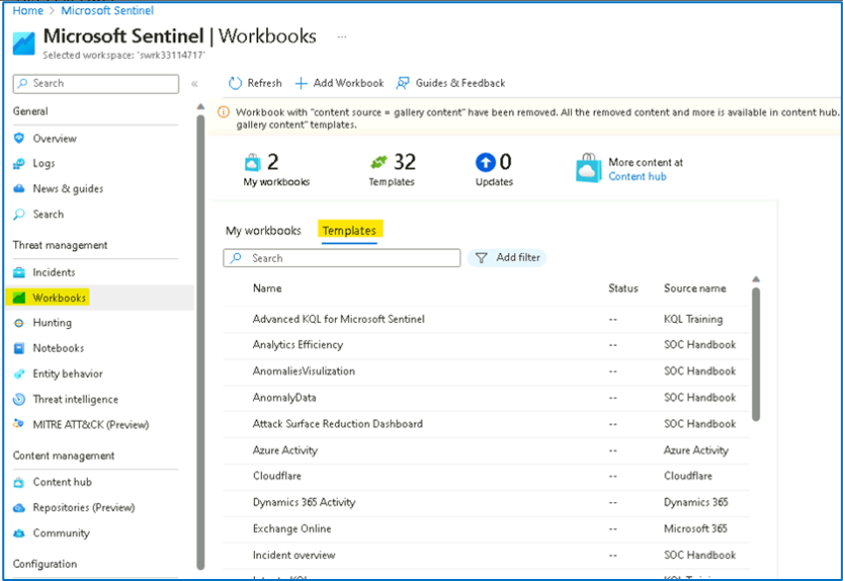

1. From the list select the **Azure Activity** template and click **View Template** button.

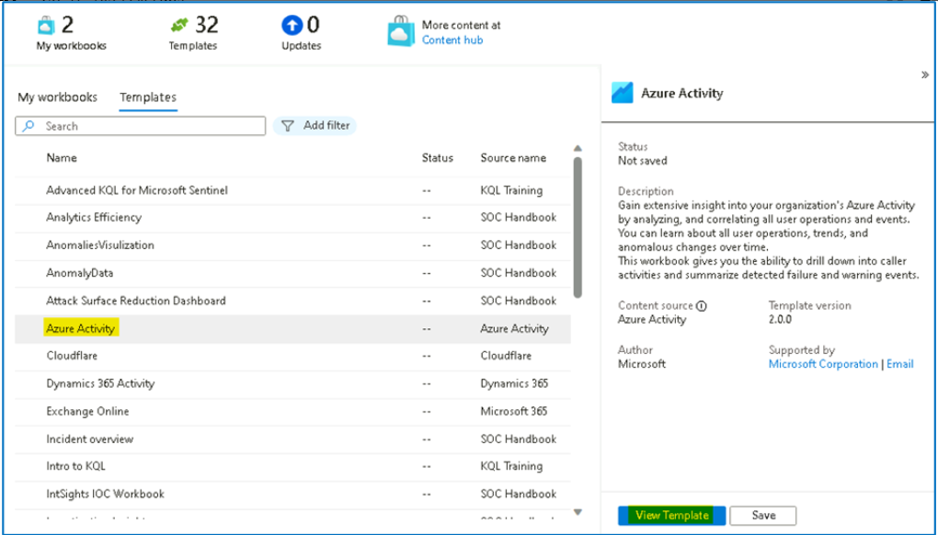

1. Review the contents of the workbook. It usually shows insights of your Azure subscription operations by collecting and analyzing the data from the Activity Log.

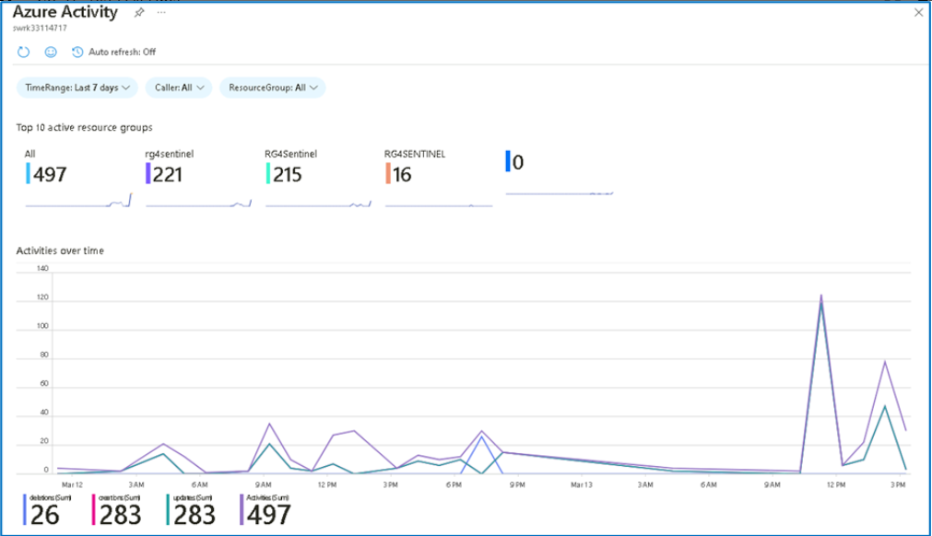

**Note**: If the log does not show any alert then follow the below steps to turn on Azure activity log.

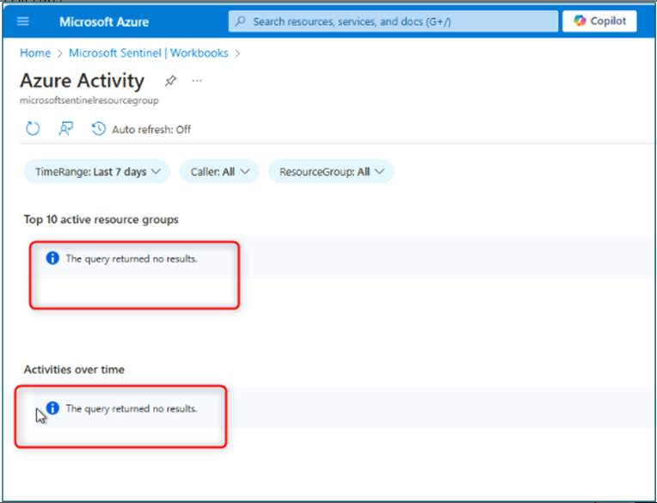

1. Navigate to Sentinel.
2. Search Data connectors under Configuration.

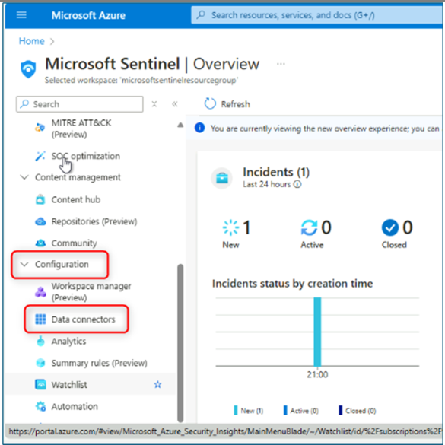

1. Under Data connectors click on Azure Activity

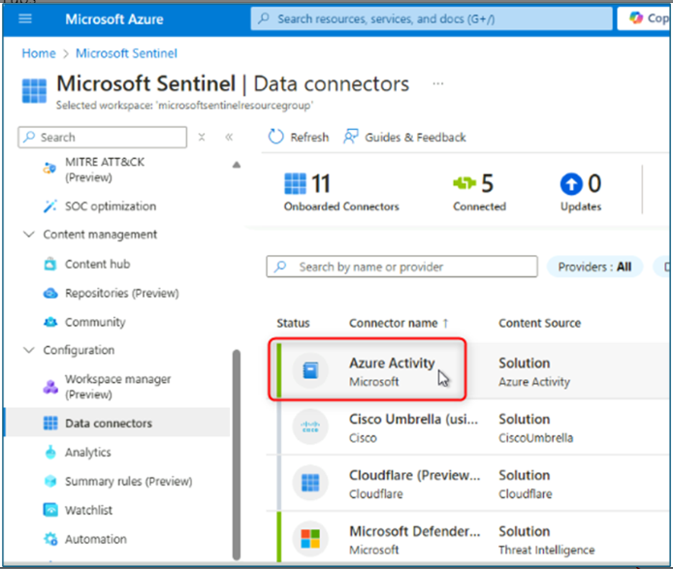

1. Click on Open connectors page.

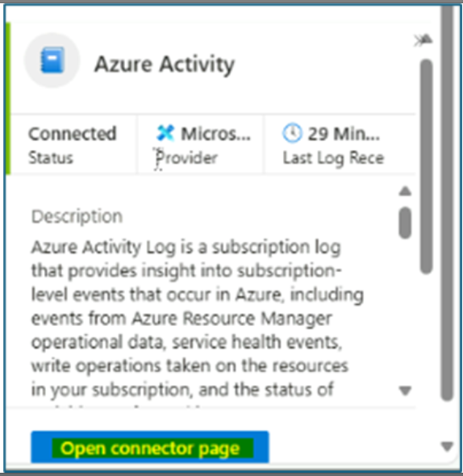

1. On the next page, click on Launch Azure Policy Assignment Wizard.

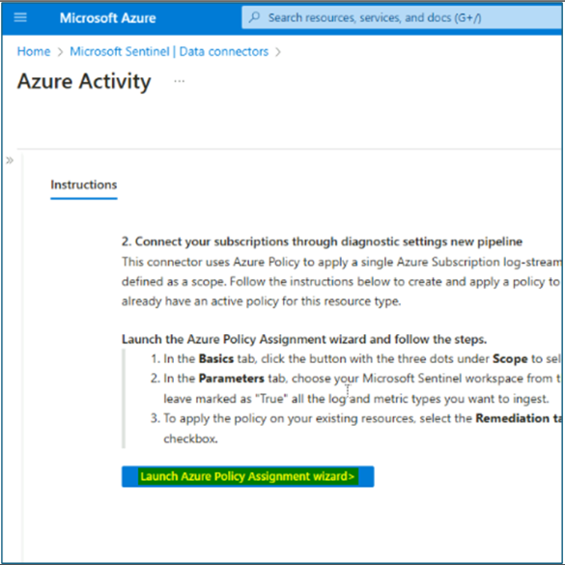

1. Under basics tab select Scope, on the scope blade select Azure subscription.

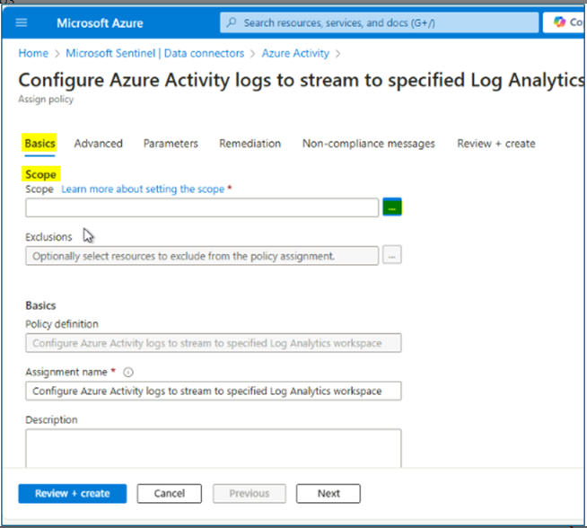

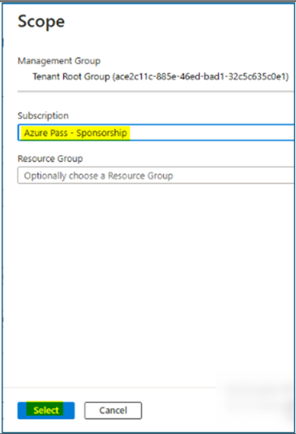

1. Under the Parameters tab select the Sentinel workspace that we created.

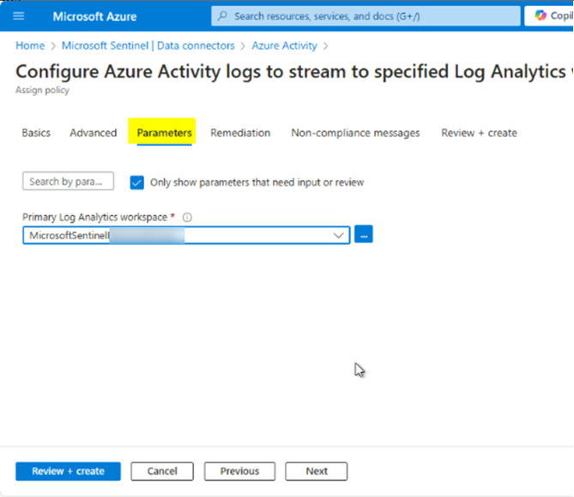

1. Under Remediation tab click on Create Remediation task, and click on Review + create.

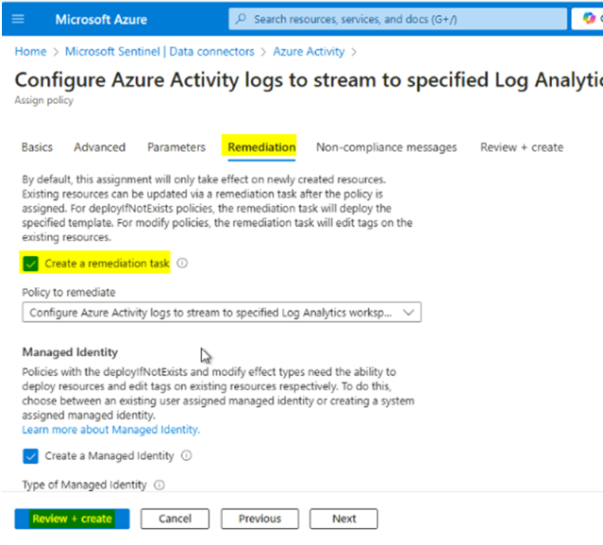

1. Click on create.

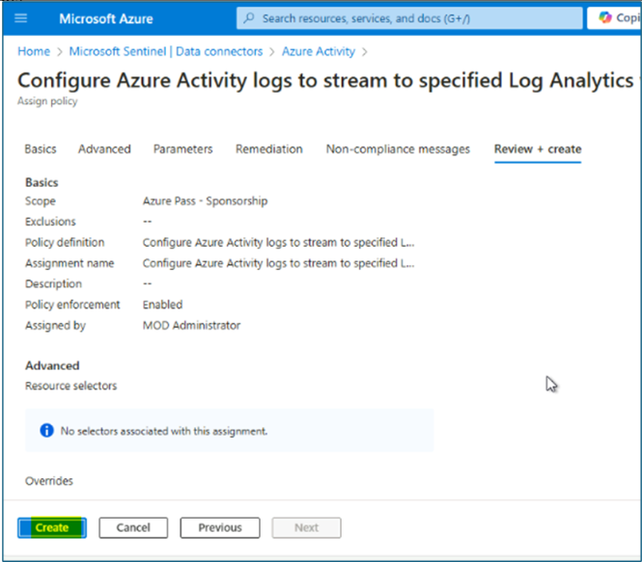

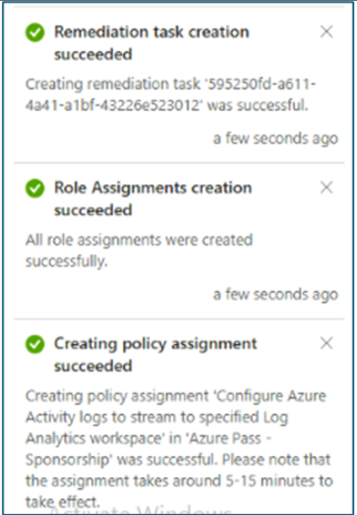

1. Close the workbook by selecting the **X** in the top-right corner.

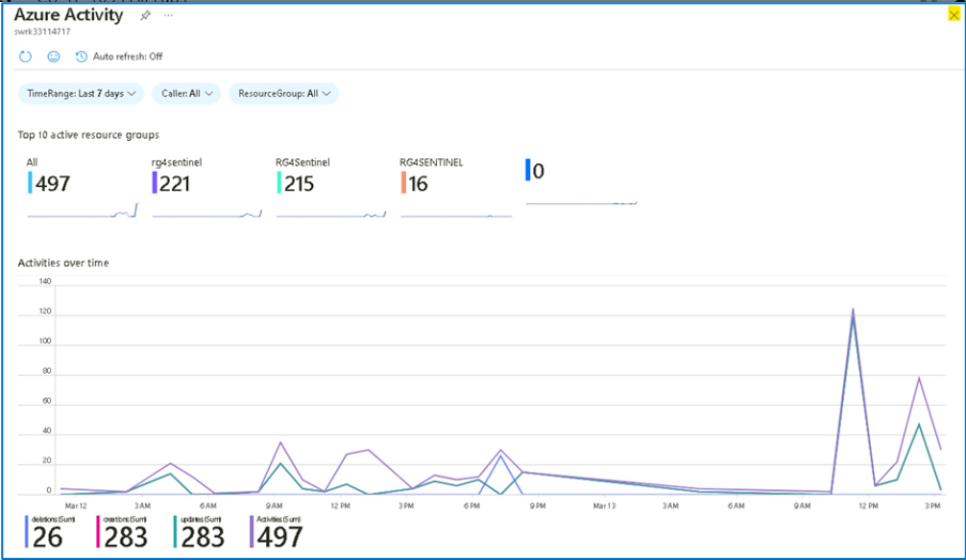

### Task 2: Save and modifying a workbook template

In this task, you will save a workbook template and modify it.

1. While in the **Workbooks,** on the **Templates** tab, click the **Save** button for the **Azure Activity** workbook.

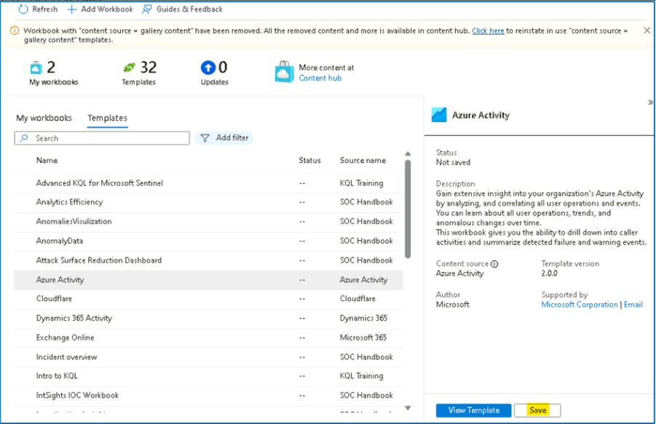

1. Leave **East US** as the default value for *Region* and select **OK**.

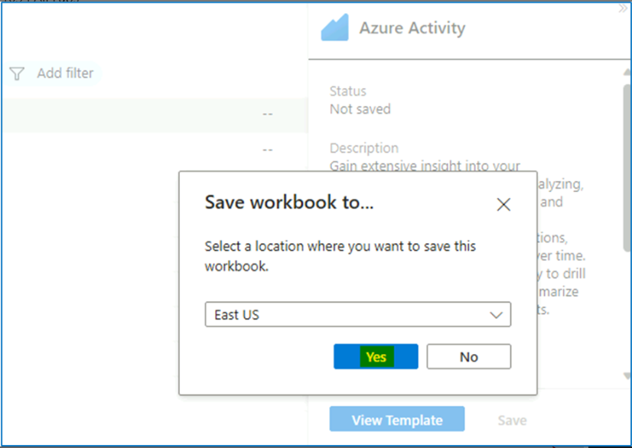

1. Select the **View saved workbook** button.

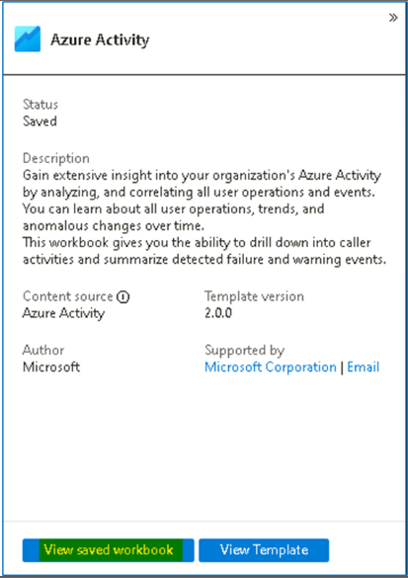

1. Select **Edit** in the command bar to enable changes in the workbook.

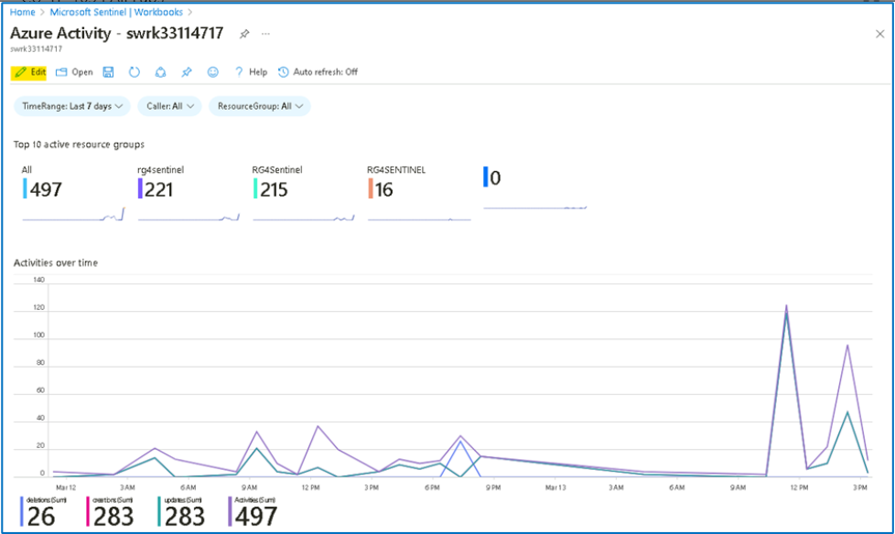

1. Scroll down to the **Caller activities**. Select the **Edit** button below the grid.

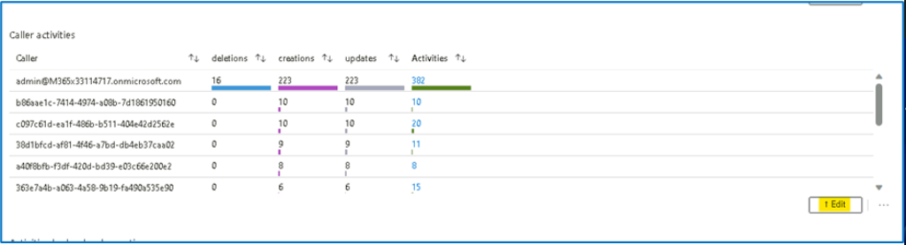

1. You can follow the next steps if there is data from the KQL query.  
   Select the **Column Settings** button, it is located to the right of the** Run Query **command bar.

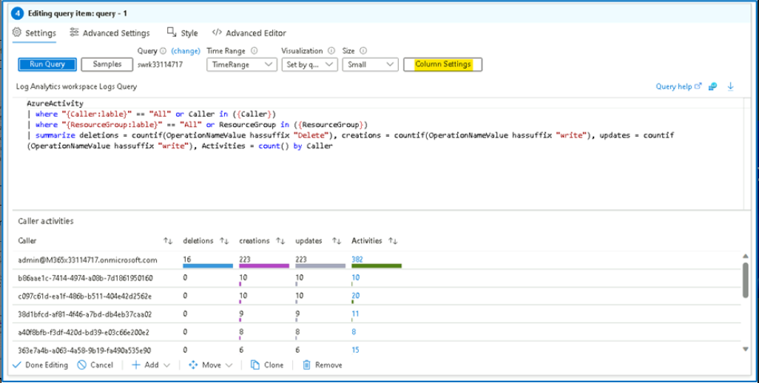

1. In the **Edit column settings** blade that appears within Columns select Activities.
2. Change the value for **Column renderer** to **Heatmap**. For **Color palette**, scroll down to select **32-color categorical**.

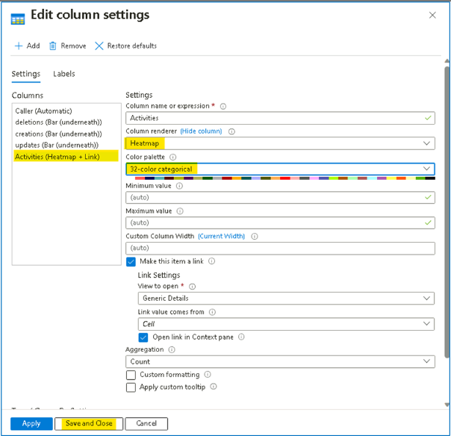

1. Select **Save and Close**. Notice the change in the *Activities* column.
2. Click on **Done Editing**

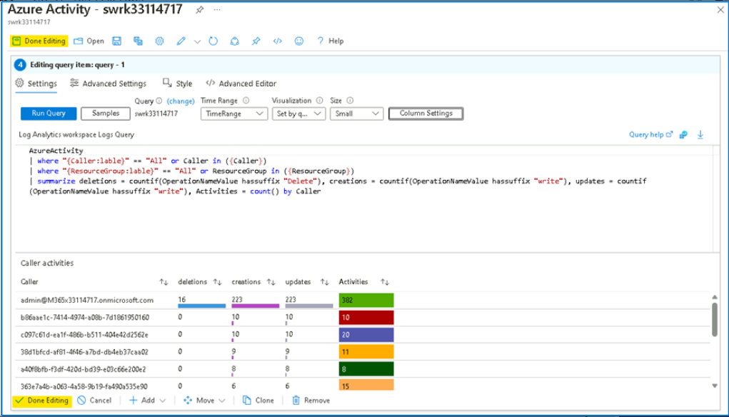

1. Close the workbook by selecting the **X** in the top-right corner.

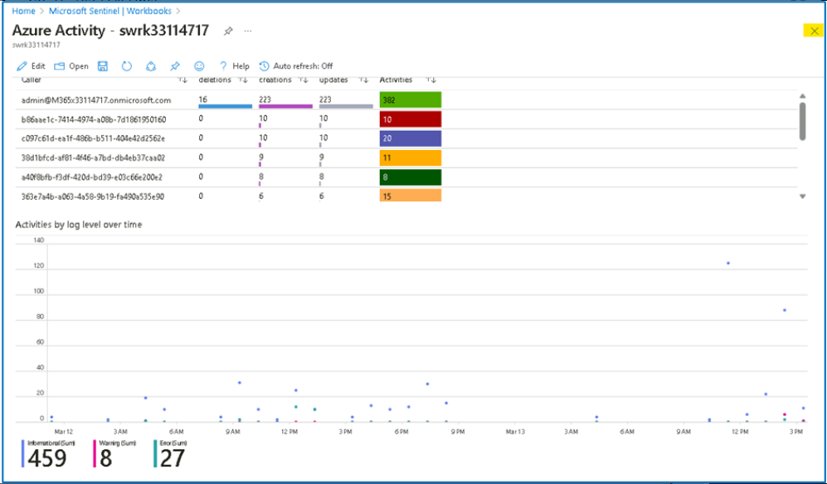

1. Close the Azure Activity workbook blade.

### Task 3: Creating a Workbook

In this task, we will create a new workbook with advanced visualizations.

1. While still on the **Workbooks** area of the Microsoft Sentinel portal.
2. Select **+ Add workbook** to create a new workbook from scratch.

**Note:** Although it is a new workbook, a startup template is used.

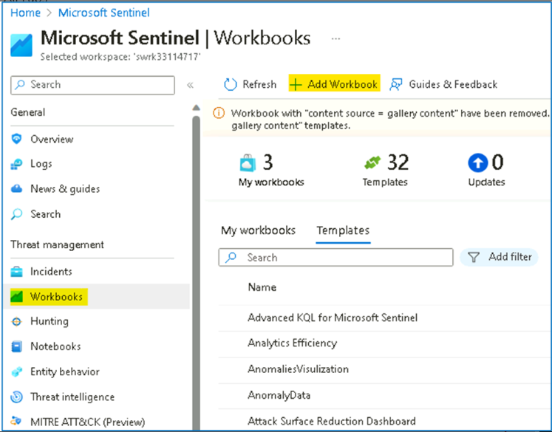

1. To edit the workbook, select **Edit**.

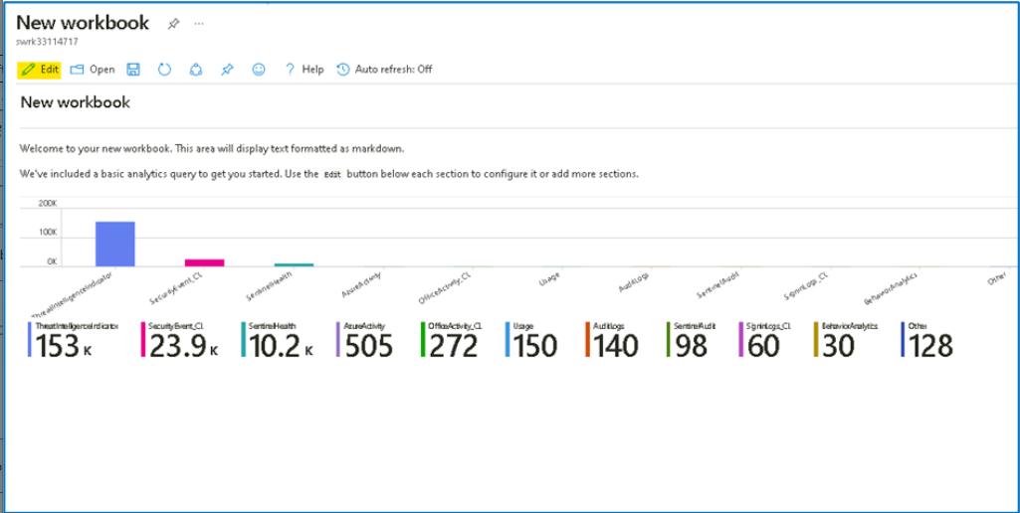

1. Select the **Edit** button below the first paragraph of the workbook.

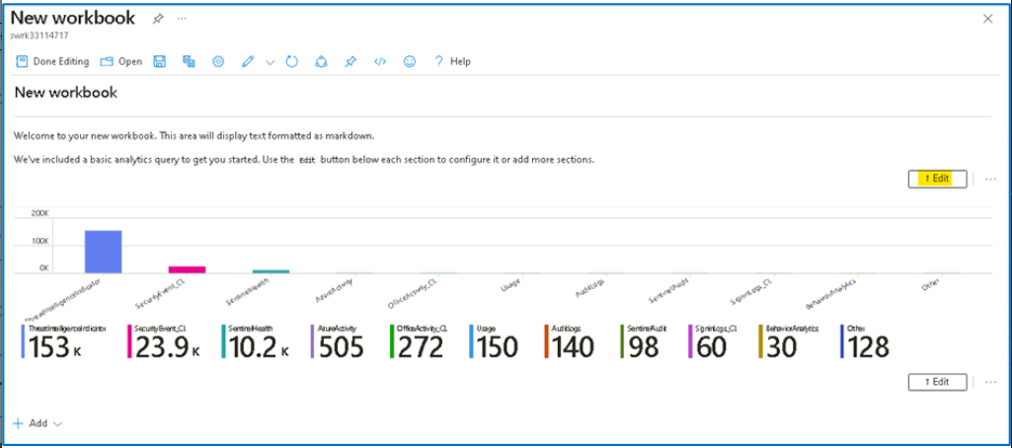

1. Type [**# My workbook**](urn:gd:lg:a:send-vm-keys) in a new line on top of **## New workbook**.
2. Select **Done Editing** on the bottom of this section, **Editing text item: text -** **2**.

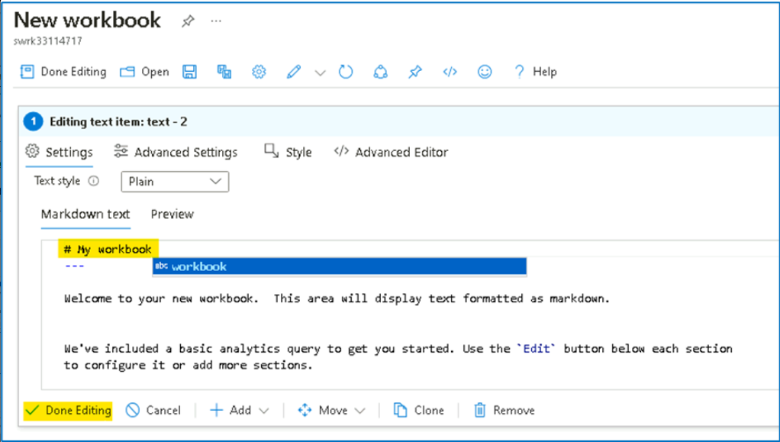

1. Notice that your header increased size and name changed.

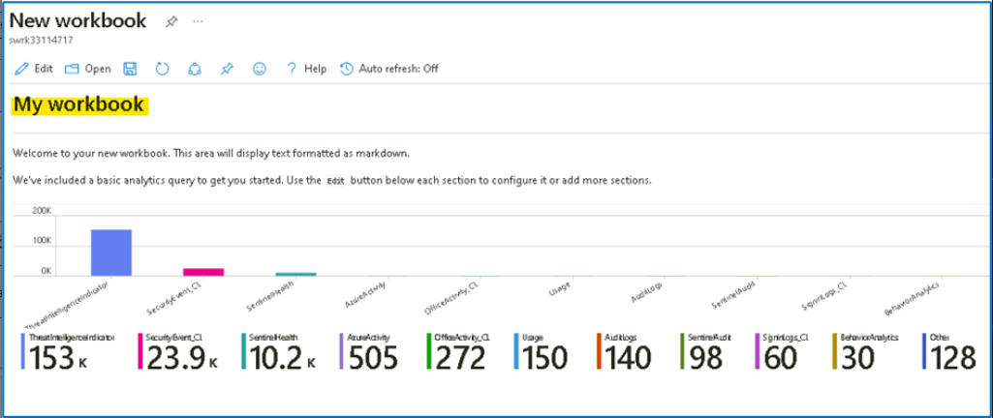

1. Click on **Edit** again and then select **Edit** below the only visible barchart graph.

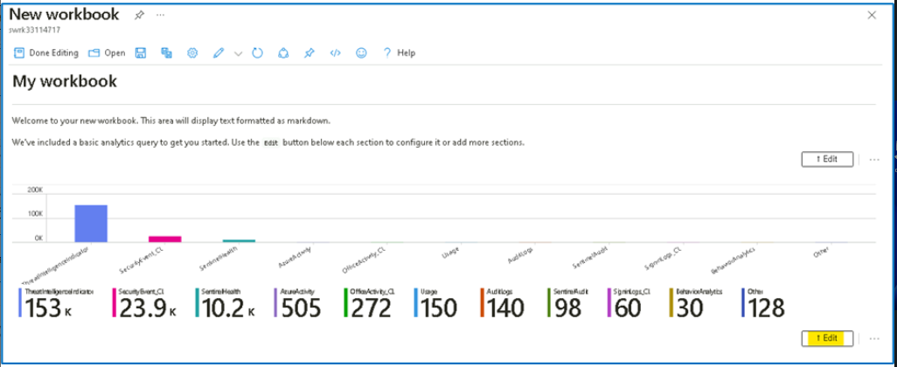

1. Review the KQL statement that provides a *union* statement of counts across all tables. Scroll down and select the **Done Editing** on the bottom menu, for the **Editing query item: query - 2**.

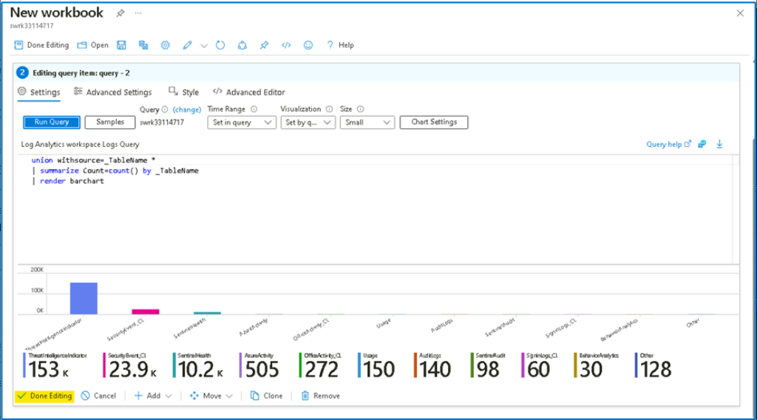

1. Select the ellipsis **...** next to the **Edit** button of the barchart graph, then select **+ Add**, then select **Add query**.

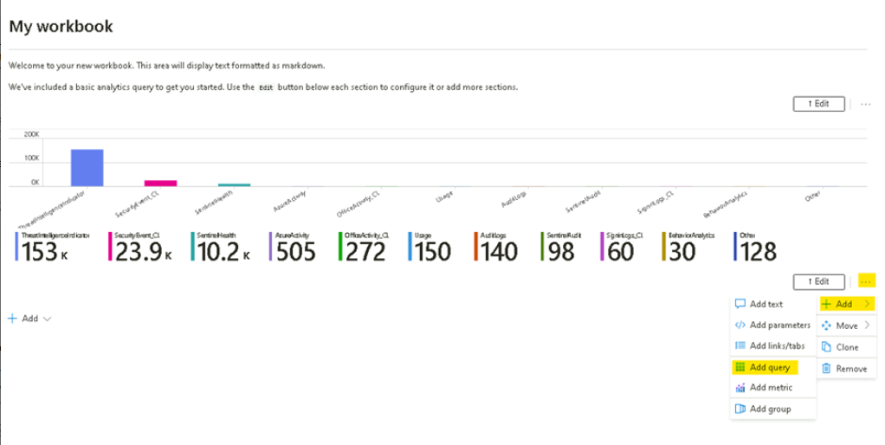

1. Type **SecurityEvent** into the query box. Change the **Time Range** to **Last hour**. Change the **Visualization** to **Time chart**.

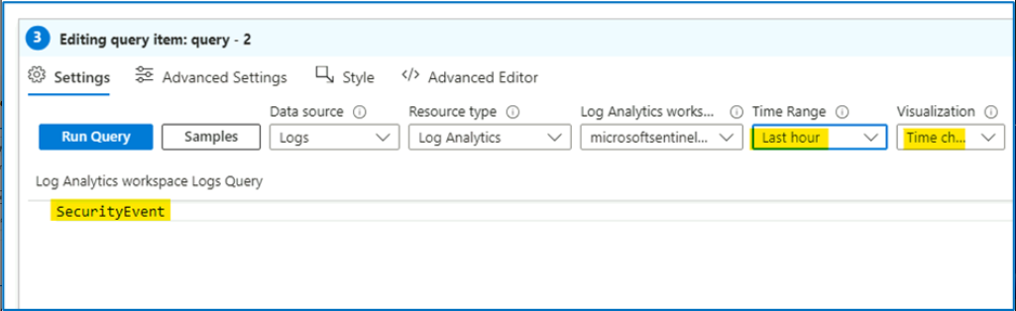

1. Select **Style** tab from the query's command bar. Select the **Make this item a custom width** box. Set the **Percent width** to **25** and **Maximum width** to **25**.

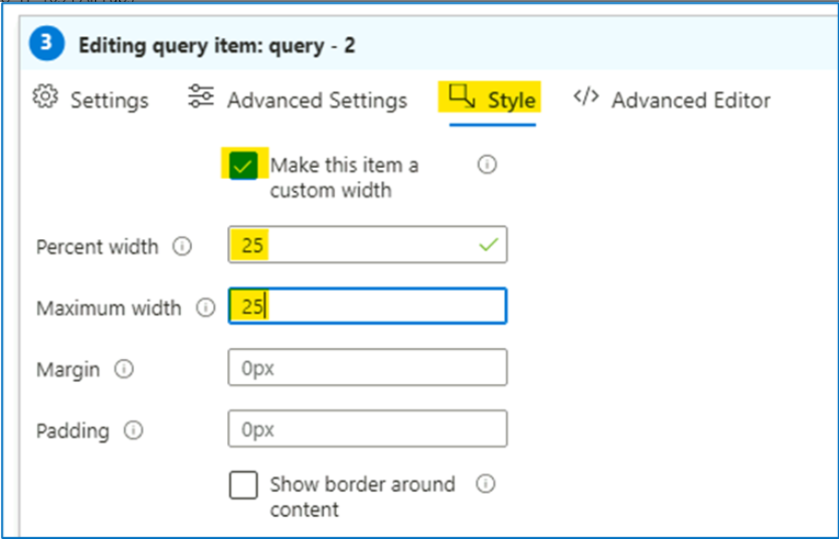

1. Now select **Advanced Settings** tab from the query's command bar. Select **Show refresh icon when not editing** box. Scroll down and select **Done Editing** on the bottom menu, for the new **Editing query item: query - 2**.

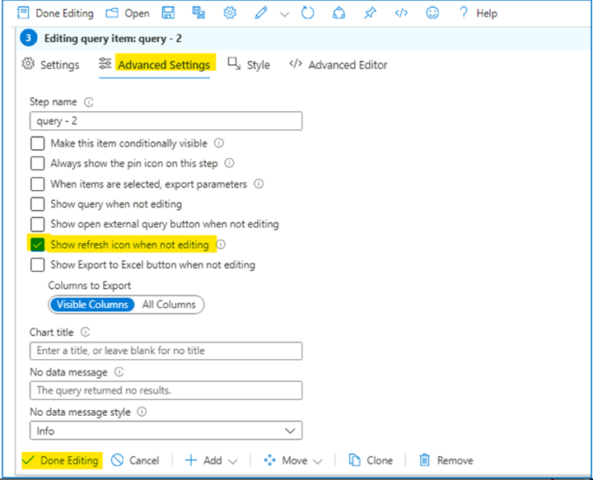

1. Scroll down and at the bottom of the workbook select **+ Add**, then **Add query**.

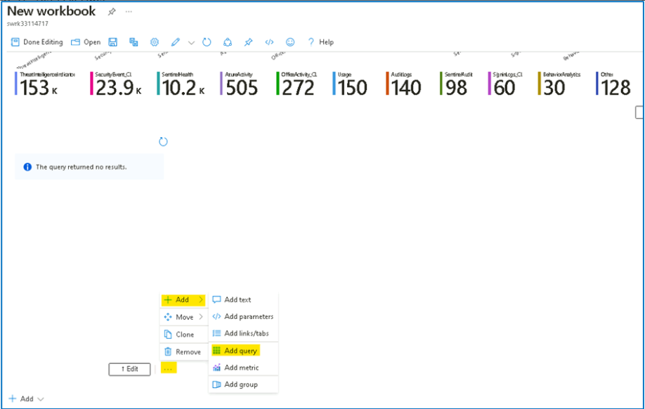

1. Type [**SecurityEvent**](urn:gd:lg:a:send-vm-keys) into the query box. Change the **Time Range** to **Last hour**. Change the **Visualization** to **Grid**.

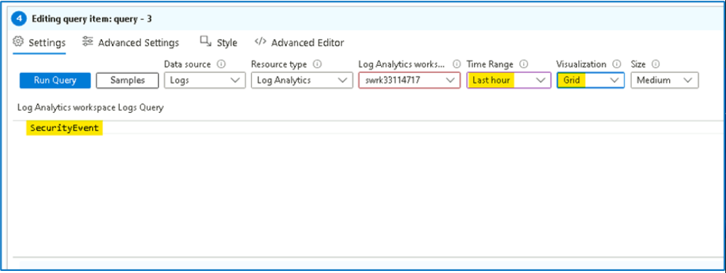

1. Select **Style** from the query's command bar. Select **Make this item a custom width** box. Set the **Percent width** to **75** and **Maximum width** to **75**. Scroll down and select **Done Editing** on the bottom menu, for the new **Editing query item: query - 3**.

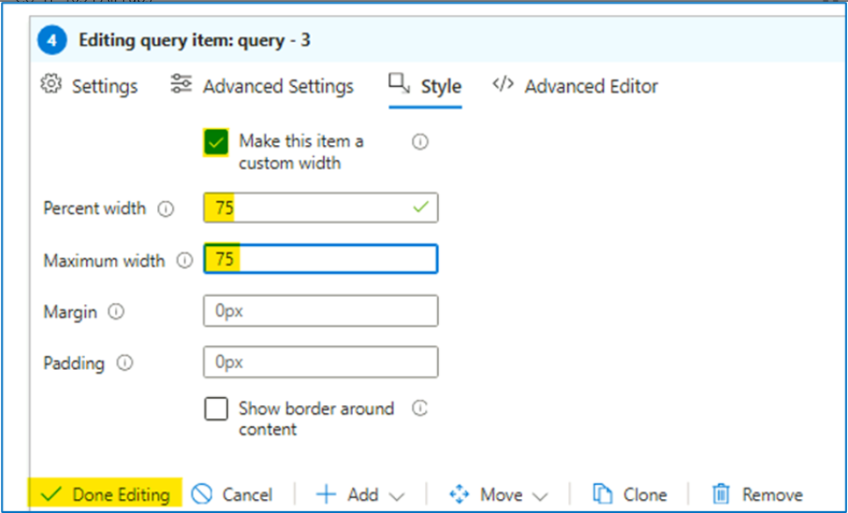

1. If required, click on **Done Editing** in Workbook's top command bar.

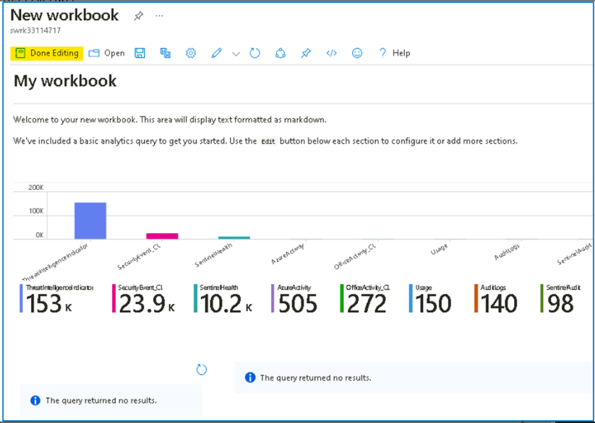

1. Select the **Save** icon, change the **Title** to [**My Workbook**](urn:gd:lg:a:send-vm-keys).

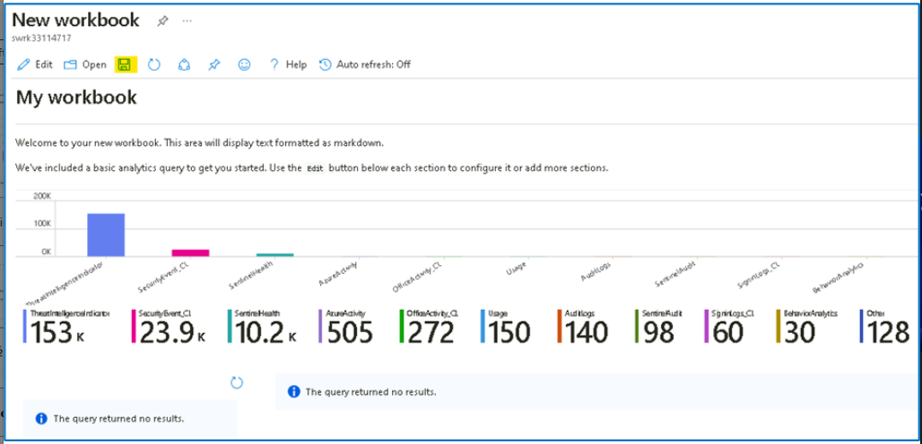

1. Select the **RG4Sentinel** resource group if needed and leave other values as default. Select **Apply** to commit the changes.

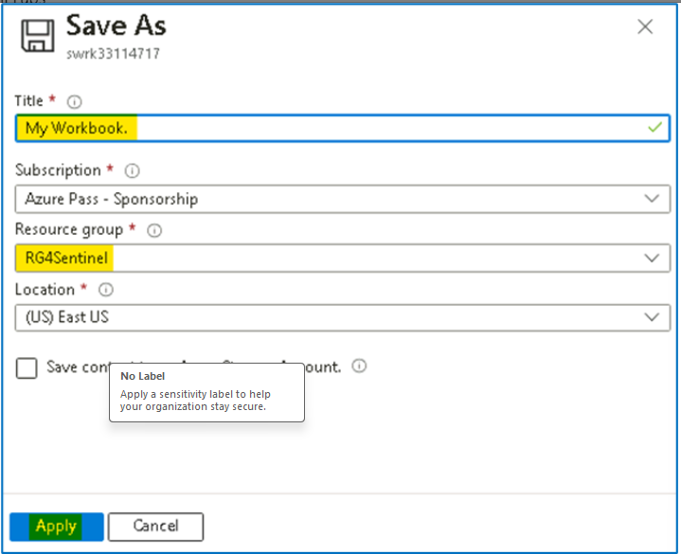

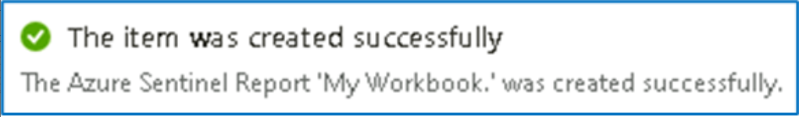

1. Close the workbook by selecting the **X** at the top-right or select **Workbooks** in the Microsoft Sentinel portal.

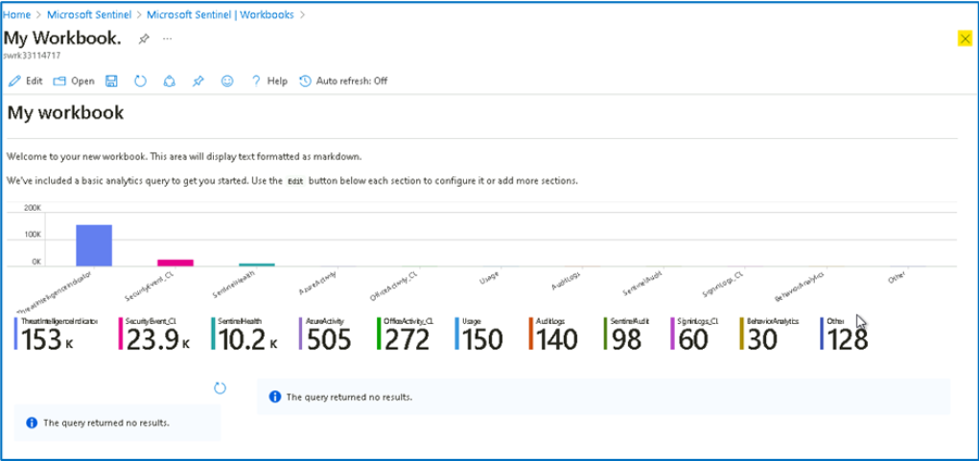

1. Back in the **Workbooks** page, you should be able to see **My workbooks**.

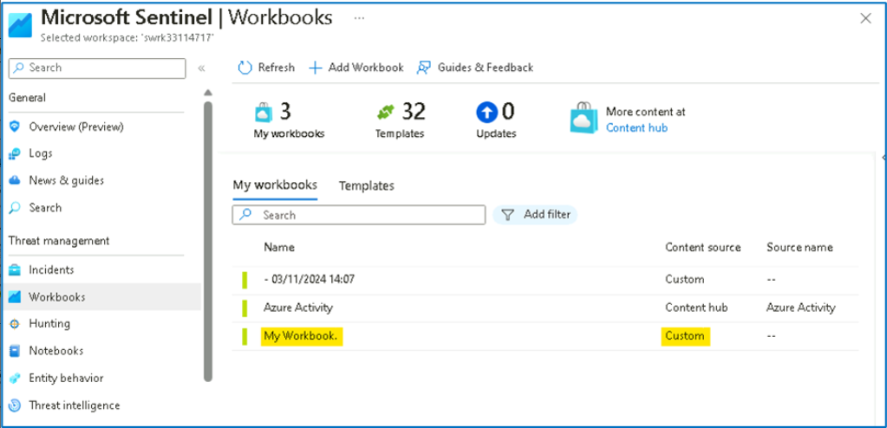

1. Select the workbook you just created, **My workbook**. On the right pane, select **View saved workbook** to review your workbook.

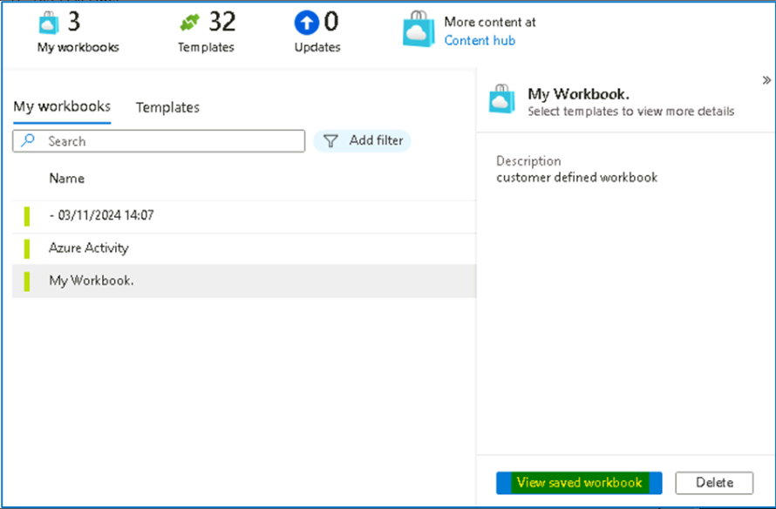

**Congratulation,** you have completed **Lab 7**